LAB 8: Configuring DHCP, DNS, and Web Services on a Server Using Cisco Packet Tracer
OBJECTIVES:
- To set up a server that provides DHCP, DNS, and HTTP (web) services within Cisco Packet Tracer.
- To learn how DHCP automatically assigns IP addresses and how DNS resolves domain names to IPs.
- To confirm that server services are functioning correctly by accessing a web page from connected client devices.
THEORY:
- Server Setup and Role:
A server is a dedicated system that provides network services to client devices. For reliability, servers are usually given static IP addresses. In this exercise, a single server is configured to offer DHCP, DNS, and web (HTTP) services. Proper server setup allows centralized management, smooth communication, and easier administration of the network.
- Dynamic Host Configuration Protocol (DHCP):
DHCP is a protocol that automatically provides IP addresses and other network settings—like subnet mask, default gateway, and DNS server—to client devices. This automation removes the need for manual IP setup, reduces errors, and supports network scalability. In this lab, the server dynamically assigns IP addresses to the connected PCs.
- Domain Name System (DNS):
DNS converts human-friendly domain names into IP addresses. Instead of remembering numbers like 192.168.1.1, users can use names like www.hcoe.com. The DNS server stores these mappings and responds to clients’ queries to direct them to the correct IP address.
- Web Server (HTTP Service):
A web server hosts web pages and provides them to clients via the HTTP protocol. It handles browser requests and serves content such as HTML files. In this lab, enabling the HTTP service allows client PCs to access a webpage through a browser.
- Combining DHCP, DNS, and Web Services:
These services complement each other for efficient network operation. DHCP handles automatic IP assignment, DNS resolves domain names to IP addresses, and the web server delivers web content. Their integration illustrates how centralized services simplify network setup and enhance usability.

NETWORK TOPOLOGY:
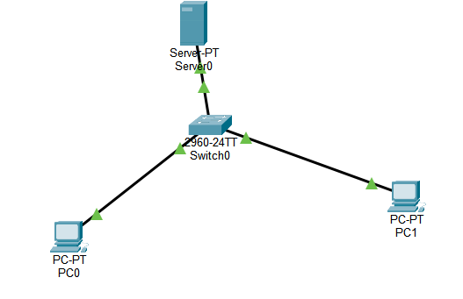
IP CONFIGURATION:
IP addressing scheme
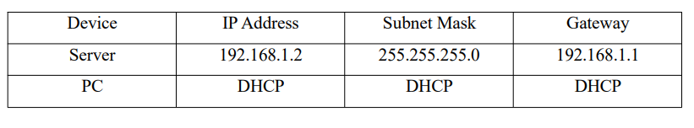

For PCs
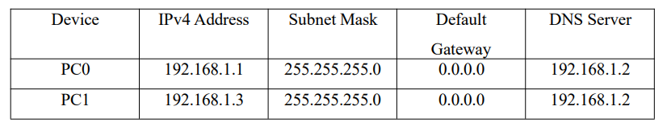

For Server


SERVER CONFIGURATION:
Step 1: Assign a Static IP to the Server
- Select the Server device in Cisco Packet Tracer.
- Navigate to Desktop → IP Configuration.
- Enter the following network details:
  - IP Address: 192.168.1.2
  - Subnet Mask: 255.255.255.0
  - Default Gateway: 192.168.1.1
  - DNS Server: 192.168.1.2
Step 2: Activate DHCP Service
- On the server, go to Services → DHCP.
- Switch the DHCP service to ON.

Step 3: Configure a DHCP Pool
Fill in the DHCP pool information as follows and click Add:
Field | Value
Pool Name | LAB_POOL
Default Gateway | 192.168.1.1
DNS Server | 192.168.1.2
Starting IP Address | 192.168.1.10
Subnet Mask | 255.255.255.0
Maximum Users | 50

Click Add
Verification:
On each PC:
- Go to Desktop → IP Configuration
- Select DHCP
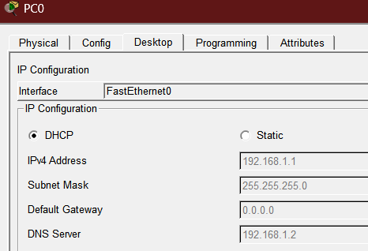
Step 4: Activate DNS Service
- Select the Server device.
- Navigate to Services → DNS.
- Set the DNS service to ON.
Step 5: Create a DNS Record
Enter the following information to map the domain name to the server’s IP address:
- Name: www.hcoe.com
- Record Type: A
- IP Address: 192.168.1.2
Click Add to save the record.

DNS Verification
On each PC:
- Open Command Prompt
- Type: ping www.hcoe.com
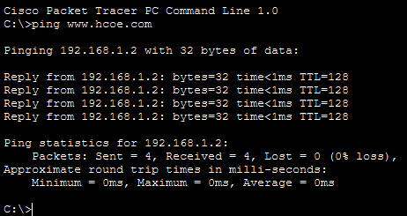
Web Server (HTTP) Configuration
Step 6: Enable HTTP Service
- Go to Server → Services → HTTP.
- Switch the HTTP service ON.
- (Optional) Modify the index.html file to customize the webpage content.
Web Server Verification
On a client PC:
- Open Desktop → Web Browser
- Enter the URL: www.hcoe.com
If everything is configured correctly, the webpage hosted on the server will load successfully.
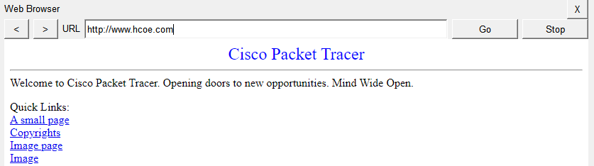

RESULT:
The server was properly configured to provide DHCP, DNS, and HTTP services. All connected client PCs obtained IP addresses automatically from the DHCP pool without manual configuration. The DNS service successfully translated the domain name into the corresponding IP address, and the hosted webpage was accessed through a browser without any errors. This confirms that all configured services operated correctly.

DISCUSSION:
This experiment provided hands-on experience in setting up core network services within a simulated environment. DHCP reduced manual configuration by dynamically assigning network parameters. DNS allowed devices to communicate using easy-to-remember domain names instead of numerical IP addresses. The HTTP service demonstrated application-layer functionality by delivering web content to clients. The lab also highlighted how these services depend on one another to ensure smooth network communication and efficient centralized management.
CONCLUSION:
The lab objectives were successfully accomplished by configuring and verifying DHCP, DNS, and web services in Cisco Packet Tracer. The experiment confirmed accurate IP allocation, proper domain name resolution, and successful web access from client systems. Overall, the activity reinforced the significance of integrated server-based services in modern networking environments.

